OBSERVING THE NIGHT SKY

Constellations

Ancient astronomers grouped stars according to the shapes they seemed to form. The shapes were usually of gods, animals or familiar objects.

The most well-known constellations are the 12 groups we know as the signs of the zodiac. These constellations follow the ecliptic (path of the Sun) and their names include Taurus (the bull), Leo (the lion) and Sagittarius (the archer).

When observed from Earth, the stars in each constellation appear to be very close to each other. But the stars that make up constellations can be located at very different distances from Earth.

e.g. The star Betelgeuse in the Orion constellation is approximately 650 light-years from Earth, whereas the star Bellatrix in the same constellation is about 240 light-years from us.

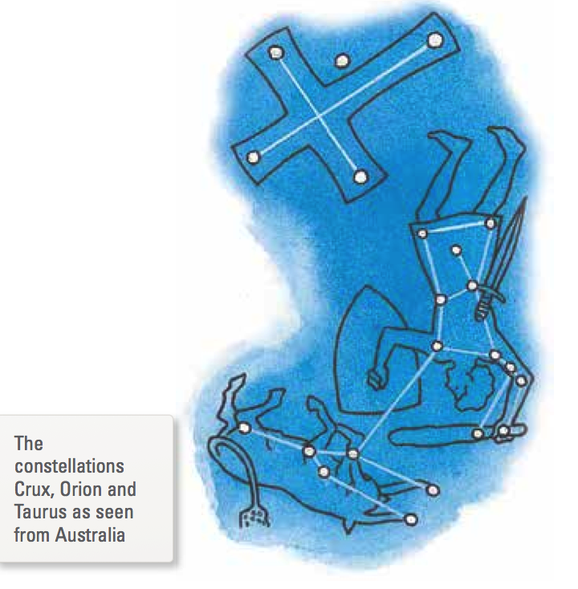

The apparent motion of the fixed pattern of stars at night, shown in the time-lapse photograph below, is due to the rotation of the Earth.

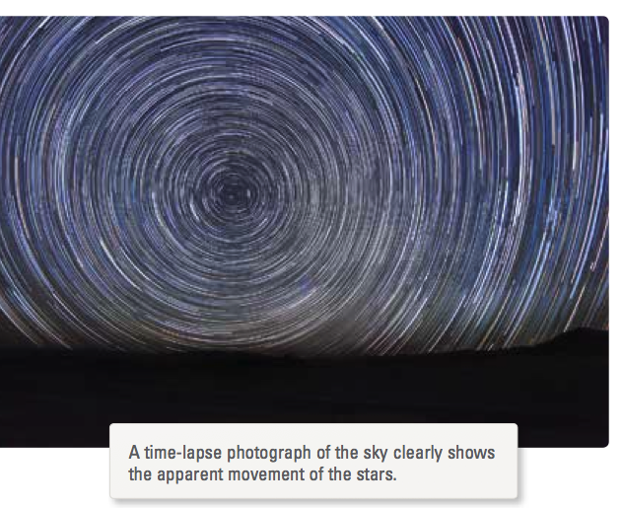

The apparent change in position of the constellations is due to the Earth’s orbit around the sun. Sky charts, sometimes called sky maps, star maps or star charts, show the position of constellations, stars and the planets from different locations for each month of the year.

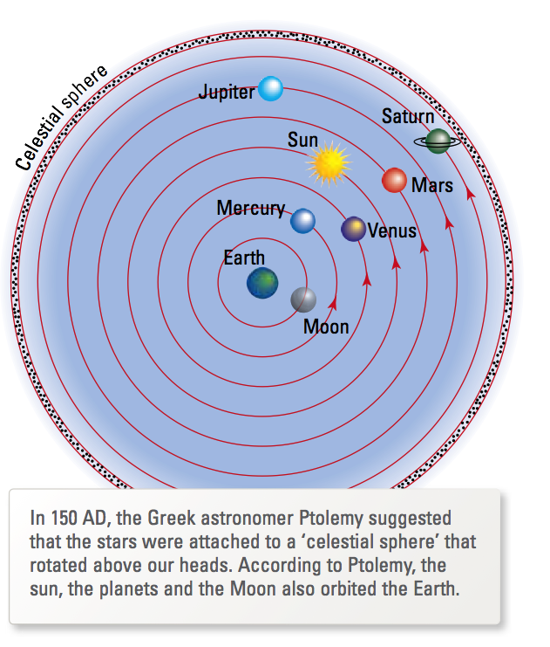

Observations using telescopes showed that many different types of objects in the sky could be identified. These included single or double stars, groups of stars called galaxies, clusters of galaxies, and clouds of gas and dust called nebulae.
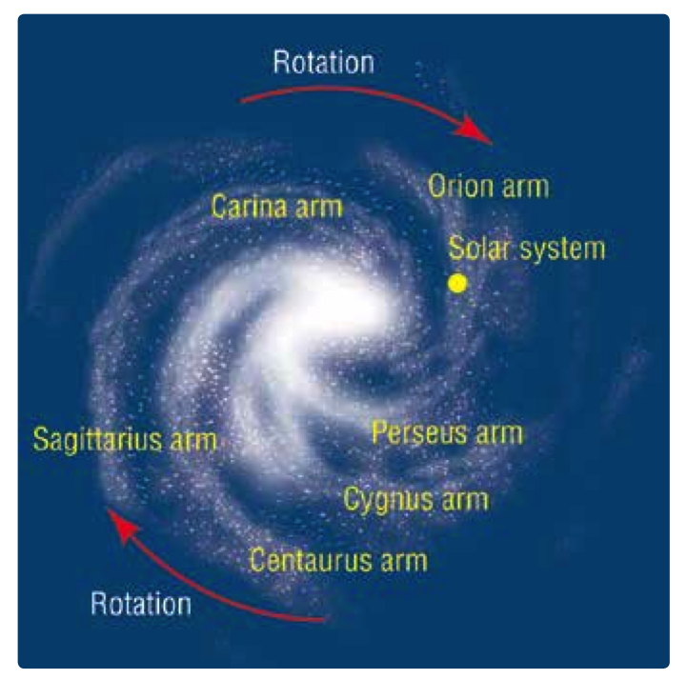
Galaxies

Stars group together in groups to form galaxies, attracted towards each other by gravitational forces.

Our own sun is one of an estimated 200 - 400 billion stars in the Milky Way galaxy.

We think there are more than 100 billion other galaxies of different sizes and shapes throughout the universe.

Each of these galaxies is home to stars at all stages of their life cycles.

The Milky Way galaxy, shown at right, is a spiral galaxy.

Our solar system is found on the Orion arm of the spiral. Due to the rotation of the galaxy, our solar system orbits the centre of the galaxy at a speed of about 200 kilometres per second.

